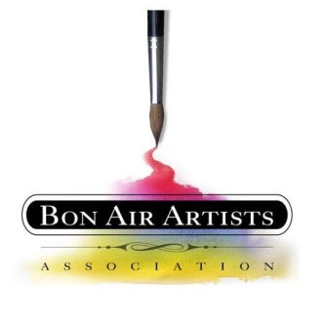
RECEPTION TICKET SALES FOR SATURDAY, MARCH 14, 2026
BAAA ANNUAL ART SHOW & SALE
INDEPENDENCE GOLF CLUB
5:00 P.M. – 8:00 P.M.

The $50 ticket includes one drink ticket, heavy Hors D’oeuvres, lots of beautiful art and guaranteed fun.
Fill this form out and treat your family, friends, business associates or any art lover.
Your Name_________________________ email address________________________________
# of tickets needed _______ ($50 each). Payable to BAAA Fundraising. Write Tickets on your check memo
Please send in the # of tickets and the money now. Very important for the food count.
Names of your guests (if you don’t know the names yet you will need to get the names to Pam Landreth by March 9th). The sooner the better. A list of paid guests’ names will be at the door.
1 - ____________________________
2 - ____________________________
3 - ____________________________
4 - ____________________________
5 - ____________________________
6 - ____________________________
7 - ____________________________
8 - ____________________________
9 - ____________________________
10- ____________________________
Add more names to the right. Thank you very much for your support.
Send your form and check to:
Pam Landreth, 6009 Country Walk Rd., Midlothian, VA 23112

