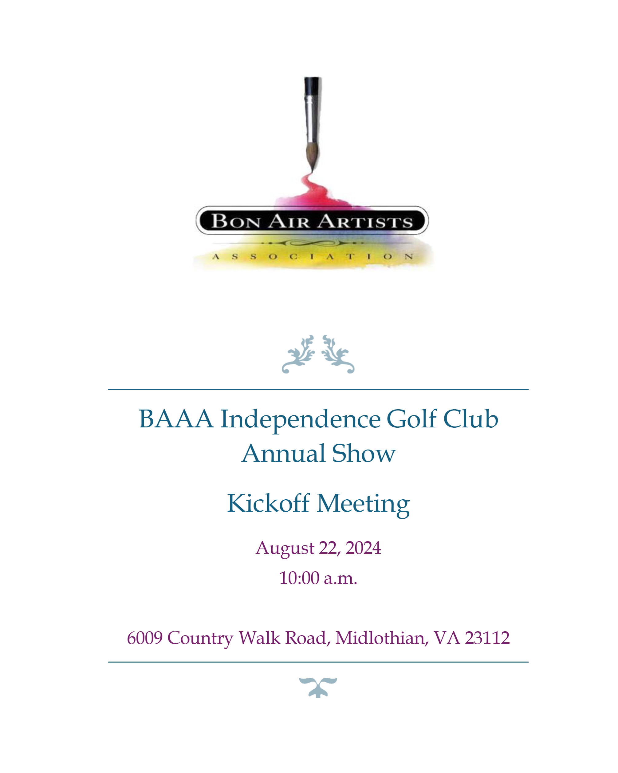

Sponsorship Form
Bon Air Artists Association 2026 Annual Art Show and Sale
at Independence Golf Club to benefit “World Pediatrics”

March 14 & 15, 2026

Your support makes a difference.

Be a part of the Bon Air Artists Association’s 2026 Annual Art Show and Sale to benefit “World Pediatrics” in our mission to transform lives through art and community!

Sponsor names will be displayed during the Art Show and Sale.
Businesses, please submit your logo to Pam Landreth, landreth@verizon.net for inclusion in event materials. Questions? Contact Pam Landreth, 703-340-0932
Businesses - Send sponsorship donations and your logo by January 1 to have your logo included on promotional flyers that will be handed out to customers of Independence Golf Club’s Tavern 19 Restaurant starting in January and running until March 15. Tavern 19 has approximately 1,000 to 2,000 customers a month. We will be printing new fliers on January 31 for those logos received after January 1.
SPONSOR NAME (as it should appear in all printed materials): ____________________________________________________________________________
PRIMARY CONTACT: _______________________________________________________
PHONE: ____________________
EMAIL ADDRESS: ___________________________________________________________
SPONSOR ADDRESS: ________________________________________________________
CITY: __________________________________ STATE: ____________ ZIP: _________
Continued on Back

PLEASE SELECT THE LEVEL OF SUPPORT YOU WOULD LIKE TO PROVIDE:
$1000____________________________ $600______________________________
$300 or preferred amount_____________________
All gifts are tax-deductible to the extent allowed by law. In-kind contributions will be recognized separately. The Bon Air Artists Association’s non-profit 501c3 number is:
EIN# 20-4589247
For each $300 donated for sponsorship, you are entitled to two complimentary tickets to our reception held on Saturday, March 14, 2026, reception, 5-8 pm, at Independence Golf Club. Sponsorships of $1,500 and above are entitled to 10 complimentary tickets.
REPRESENTATIVE(S) WHO WILL ATTEND THE EVENT: __________________________________________________________________________
__________________________________________________________________________
__________________________________________________________________________
__________________________________________________________________________
__________________________________________________________________________
__________________________________________________________________________

Please submit checks, made payable to BAAA Fundraising, please note “BAAA 2026 Art Show Donation” on memo line of your check and mail to,
BAAA, c/o Pam Landreth
P.O. Box 72932
Richmond, VA 23235

